HDRPROTAL
- LOGIN

- MAINMENU
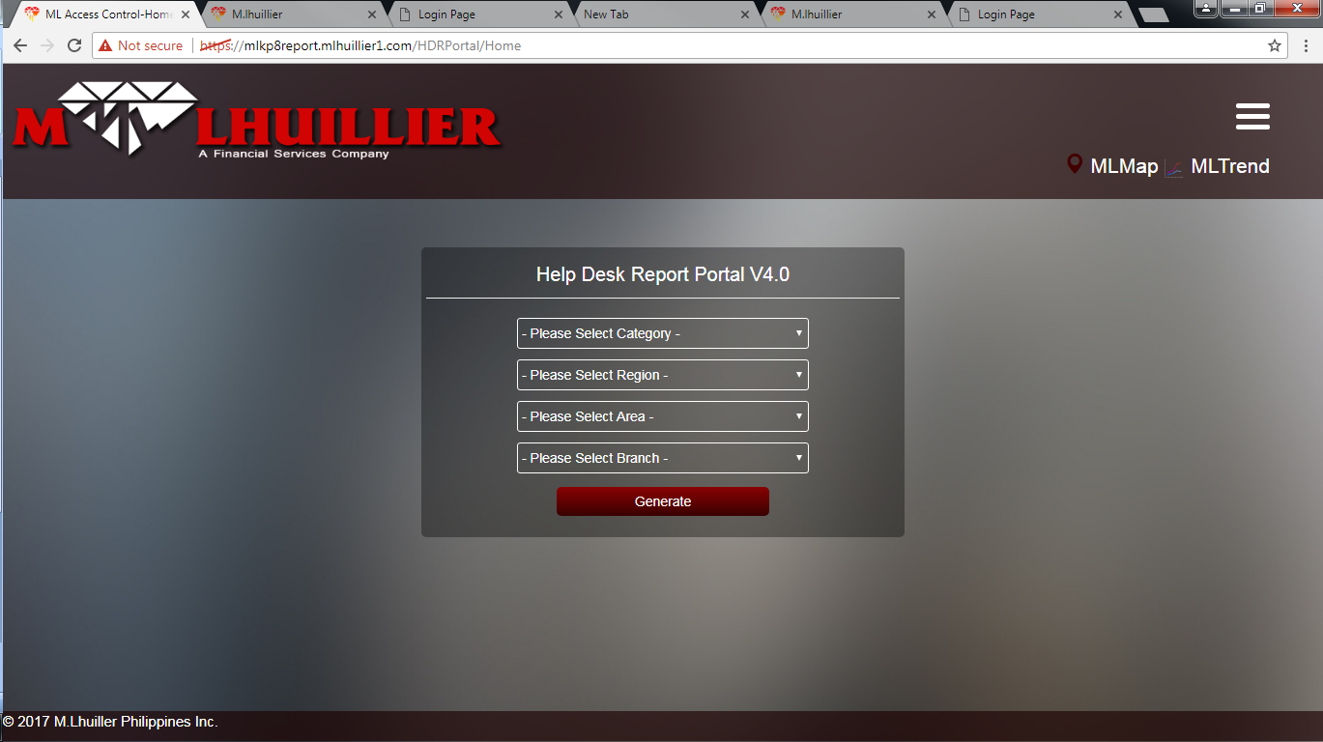

- REPORTS CATEGORY
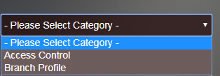
- REPORTS FORMAT – Access Control
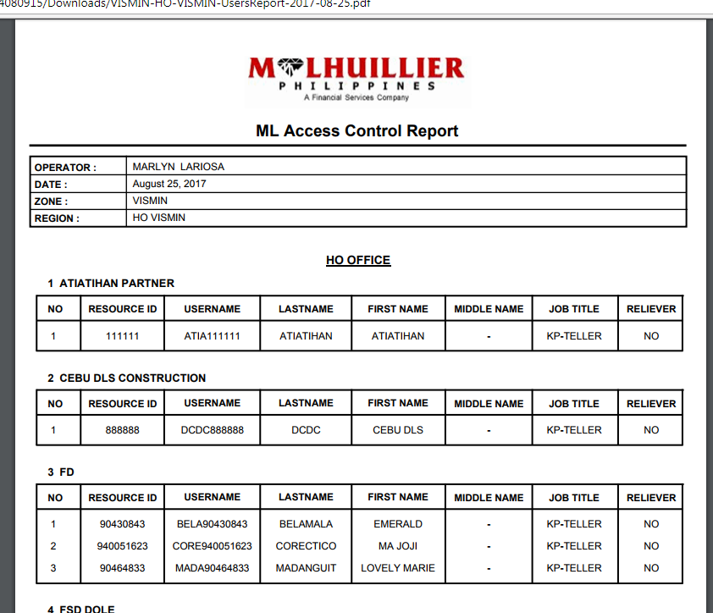

- REPORTS FORMAT – Branch Profile
